Chapter 4 – Logon Sessions
Chapter 2 introduced the logon session and put some shape around it. Produced by the LSA, a logon session represents an instance of a particular principal on a particular machine, very much like the badge one obtains from a security guard when entering a secure building. The easiest type of logon session to imagine is an interactive logon session (in which Alice hits Control-Alt-Delete and logs in via the console), but there are other equally important types of logon sessions that are covered in this chapter. Recall that the motivation for using a logon session is to allow the operating system to perform work on behalf of the logged-on principal without constantly having to verify the principal's identity (by asking for a password, for example).
Each logon session is represented by a physical data structure managed by the operating system and identified by a locally unique identifier (LUID), which is simply a 64-bit integer whose uniqueness is bounded by the machine. This allows us to distinguish one logon session from another on a particular machine. Logon sessions never extend across machine boundaries, so in order for a process running under Alice's logon session on AlicesMachine to access secured resources on BobsMachine, some magic must occur. BobsMachine needs to ascertain the identity of the user represented by the logon session on AlicesMachine; in other words, BobsMachine needs to authenticate Alice. The logon session on AlicesMachine will normally cache Alice's credentials to streamline this procedure, which allows the system to do work for Alice (potentially over the network) without constantly having to prompt her for a password. To protect Alice, the logon session on BobsMachine won't normally have access to these cached credentials, thus limiting the radius where Alice's credentials may be used to a single network hop. Figure 4.1 shows an example of logon sessions created on various machines, and their relation to one another.
You may be surprised at the number of logon sessions that exist at any given time on a typical machine, especially if that machine happens to provide services to other machines on the network. This chapter discusses these various logon sessions in chronological order so you can get a feel for the environment likely to be present on a machine at any given stage in its life cycle. Before beginning, take a look at the flowchart in Figure 4.2. The order in the figure shows a typical progression that emphasizes that a Windows machine is quite functional without an interactive user present at all.
The basic order of events is as follows. Taking AlicesMachine as an example, the System logon session is the first to appear; it is born early in the boot sequence as AlicesMachine comes to life. This logon session is designed to bootstrap the operating system. As part of this bootstrapping, a process running within this initial logon session creates new logon sessions for daemons (also known as services) configured to autostart as distinct principals. The entity that starts these daemons is known as the System Service Control Manager (SCM), and most system-level Windows developers are familiar with the basic services it provides.

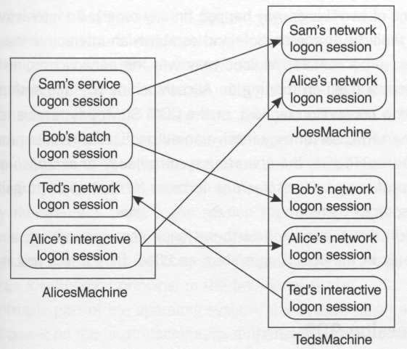
Figure 4.1.Logon sessions
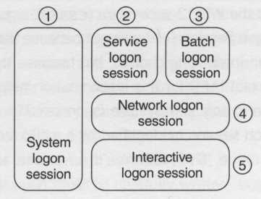
Figure 4.2. Sample logon session flowchart

After these logon sessions have been created and the daemons are happily running, one of two things may happen (in any order). An interactive user may happen to walk up to the console and establish an interactive logon session, or a process on a remote machine may (via the network) request a secured resource from a daemon running on AlicesMachine (the file system redirector may receive a connection request, or the COM SCM may receive an activation request, or an RPC server may receive an authenticated remote procedure call, etc.). In all these cases, the operating system needs to establish a logon session for the client on AlicesMachine in order for that client to gain access to secured resources there.
Let's drill down into each of these logon sessions in turn, and see what role they play in the operating system and how they affect you as a systems developer.

Logon Session 999
The operating system establishes a special logon session at boot time, which has a hardcoded identifier: number 999, or 0x3E7 in hexadecimal (just search for system_luid in the winnt.h header file to find this identifier). This is the System logon session that was described briefly in Chapter 3, and (at least by default) it houses the entirety of the user-mode processes that make up the trusted computing base. This includes the Local Security Authority subsystem (lsass.exe), the logon process (winlogon.exe), the RPC subsystem (rpcss.exe), and the Win32 subsystem (csrss.exe). The reason I chose to title this section Logon Session 999 was not because the number 999 is important (although it's an interesting choice), but because the fact that you can put your finger on the exact LUID for this logon session helps to emphasize that on each machine there is only one System logon session.
The System logon session is identified by a well-known SID (S-1-5-18) and a human-readable name, SYSTEM. You'll never see an account for SYSTEM listed in User Manager, because it has no account in the security database; the groups and privileges assigned to the System logon session are fixed by the operating system, and I can't imagine choosing the hours in which it is allowed to log in to the machine. However, you will see SYSTEM listed in various ACL editors (the user interface you see when editing security settings on files, registry keys, shares, and so on). This means that you can grant access to the System logon session just as easily as any other real principal or group. Often I'm asked the question "What's the password for the SYSTEM account?" It should be clear by now that this question is moot. On any given machine, SYSTEM simply represents a single logon session (number 999); this session is established implicitly at boot time by the operating system, so a password is unnecessary. Just think of S-1-5-18 as specifically identifying the System logon session versus identifying a principal in the traditional sense.
As an intrinsic part of the operating system, the System logon session has tremendous power on the local machine. Its authorization attributes include the Administrators alias, and therefore all the privileges normally granted to that powerful alias, including the ability to read and write any file on any local NTFS partition, regardless of the security settings on the file, as well as the ability to change the security settings on those files. (These are simply the Backup, Restore, and Take Ownership privileges, by the way, but it gives you a feel for the awesome power that an Administrator wields.) Beyond these privileges, the System logon session is also granted other privileges, the most important of which is the TCB privilege (better known to most administrators by its friendly name, "Act as part of the operating system"), which implies that code running under the System logon session acts on behalf of the operating system and therefore has the capacity to help enforce or to subvert the security policy of the machine. (A definition of TCB is provided in the glossary.)
Because of the power of the System logon session, it is often convenient to write code that executes in the warm sanctuary that it affords. However, code that runs in this logon session must be carefully written; bugs in code that runs in the TCB are clearly more dangerous than bugs outside. My own personal preference is to avoid running my own code in the System logon session unless it is absolutely necessary, and even then I prefer to keep this to a minimum. One approach is to factor out the privileged code into a COM server (although any interprocess communication mechanism would do) and make calls into the server when you need privileged work done. This allows precise unit testing of the critical piece of code you'll be injecting into the TCB. You'd be surprised at how little code you really need to inject into the TCB to move really big mountains in Windows.
So how does one get code injected into the System logon session? How does one get code injected into any particular logon session? This is discussed in Chapter 2. You must have a process that's already running in that logon session either load your code directly via a DLL or launch a separate process by calling CreateProcess. Whenever you call CreateProcess, the new process always inherits the logon session of the creator's process. It turns out that the System SCM runs in the System logon session and is happy to call CreateProcess to inject a new process into the System logon session as a service. So the first option is to write a few extra lines of code to make your application into a service. (You'll need to call StartServiceCtrlDispatcher and friends to get along with the SCM, and your setup program will need to call CreateService to install your application into the service database.)
The second option is to leverage an existing process that is already running in the System logon session (one that's more forgiving). Simply ask it to call CreateProcess on your behalf. This second option is convenient because you don't need to code to the service APIs, but is problematic because there aren't many existing services that are willing to do this for you. If you have several processes that need to run in the System logon session, you could potentially write a single bootstrapping service to be launched by the System SCM, which in turn would call CreateProcess to spawn other processes running in the System logon session. I'm using this example to emphasize that the System logon session works just like any other logon session; it's not special other than its elevated level of privilege and the fact that it happens to be the bootstrapping logon session. I'd personally avoid dumping lots of processes into the TCB for the reasons mentioned earlier.
One strange thing about SYSTEM is that it appears as though it would have the same SID everywhere on the network. What happens when an application running under the System logon session on AlicesMachine tries to access a remote file (via a file share) on BobsMachine? If the SID for SYSTEM is S-1-5-18 on AlicesMachine as well as all other machines on the network, there is no way for Bob (the administrator on BobsMachine, say) to expose a file share (or any other secure resource) and grant or deny access to AlicesMachine versus SarahsMachine versus RonsMachine. Because of this and other issues, prior to Windows 2000 the SYSTEM account had no network credentials at all, and therefore couldn't be authenticated. There was no way to tell one machine from another on the network, other than by looking at its network address (which is easily faked and therefore can't be used for securing resources). Windows specifically provides a couple of back doors that allow you to satisfy unauthenticated requests for file shares and other secure resources, but this isn't a pretty solution. (These back doors – the NULL session and the Guest account – are discussed in Chapter 7.)
This problem does not exist for Windows 2000 machines running in a Windows 2000 domain. In this case, each machine is a first-class principal in the domain and has a dual identity. On the local machine, the System logon session is identified via our old friend, SYSTEM (S-1-5-18); this is good, because you wouldn't want existing code that relied on this identifier to break. However, things look different on the network. Here's a concrete example: Assume that AlicesMachine and BobsMachine (both Windows 2000 boxes) are members of Foo (a Windows 2000 domain), and that an application running in the System logon session on AlicesMachine contacts BobsMachine over the network. After authentication, BobsMachine will see the request as coming from a domain principal named Foo\AlicesMachine, with a unique SID scoped by Foo (as opposed to the well-known SID S-1-5-18). This would work even if BobsMachine was in a different domain, as long as the appropriate trust relationships were in place (which is pretty hard to screw up in Windows 2000, because all domains in a forest share transitive trust relationships, and typical organizations will likely have a single dominant forest).
This behavior makes it appear as if the System logon session develops a multiple personality disorder in Windows 2000, but it is clearly a very useful feature. In fact, machines are now listed alongside users as first-class principals in the domain, and can be assigned to groups (consider that AlicesMachine will be in a group named Foo\Domain Computers by default). So in Windows 2000, when you want to grant access to your local operating system (that is, the System logon session on your machine), you must grant access to SYSTEM. When you want to grant access to AlicesMachine (that is, the System logon session on AlicesMachine), you grant access to XXXX\AlicesMachine, where XXXX is the domain to which AlicesMachine belongs.

Daemon Logon Sessions
So far we've established that the first logon session to be created is the System logon session. But often other logon sessions are created as the operating system starts; in particular, the System SCM creates logon sessions for services that are configured to run as distinguished principals. For an example of how this works, take a look at the CreateService API that setup programs use to install applications as services:

SC_HANDLE CreateService(
SC_HANDLE hSCManager, // in, indicates host
LPCTSTR lpServiceName, // in, short name
LPCTSTR lpDisplayName, // in, pretty name
DWORD dwDesiredAccess, // in
DWORD dwServiceType, // in, interactive/etc.
DWORD dwStartType, // in, auto/manual/etc.
DWORD dwErrorControl, // in
LPCTSTR pBinaryPathName, // in, path to EXE
LPCTSTR lpLoadOrderGroup, // in, optional, for drivers
LPDWORD lpdwTagID, // in, optional, for drivers
LPCTSTR lpDependencies, // in, optional, multisz
LPCTSTR lpServiceStartName, // in, optional, principal
LPCTSTR lpPassword); // in, optional, password

This function simply takes the settings given it and updates the registry of the machine on which the service is being installed (the machine was indicated when the hscManager handle was acquired via OpenSCManager). This provides the System SCM with all the information it needs to create an appropriate environment and allocate a process for your service either at boot time or in response to a call to the StartService API.
The lpServiceName and lpDispiayName parameters are the short and pretty names, respectively, of the service being installed. The dwDesiredAccess parameter is the access mask by which you specify exactly what you intend to do with the handle returned from the function. The dwServiceType parameter allows you to specify whether or not you plan on exposing multiple services from a single process; more important (for our purposes), this parameter allows you to choose the window station allocation policy that the System SCM will use when creating a process to host your service, specifically via the presence or absence of the service_interactive_process flag (see Chapter 5 for a thorough discussion of window stations). The dwStartType parameter allows you to specify whether the service starts at boot time (service_auto_start) or only when prompted via the StartService API (SERVICE_DEMAND_START). The dwErrorControl parameter allows you to choose how critical a startup failure really is to system Startup, and the lpBinaryPathName and lpDependencies parameters allow you to specify the EXE image that holds your service code, and any dependencies your server may have (rpcss is important to list if you're going to act as an RPC or COM server). The lpLoadOrderGroup and lpdwTagID parameters are only used for protected mode drivers, so you'll normally pass NULL for both of these.
Finally, lpServiceStartName and lpPassword allow you to specify on whose behalf the process should run. Pass NULL for both to run as SYSTEM. If you specify a distinguished authority and principal (Foo\Bob, say), CreateService will store "Foo\Bob" in the service database in the registry, but will tuck the password away in a local password stash maintained by the LSA to which only administrators (and therefore the System logon session) have access (see the appendix for details of programming against this stash). In this case the index into the password stash is based on the short name of the service (for example, a service with a short name of MyService would have its password stored at index _sc_MyService).
When the service needs to be started (either at boot time or via an explicit request initiated via a call to StartService), the System SCM looks up the authority and user name from the registry, and passes this information (along with an index into the password stash) to the LSA. The LSA attempts to authenticate the principal using the stashed password, and upon success, creates a brand-new logon session for Foo\Bob. The SCM takes this new logon session and launches the EXE that was specified as the image name for the service, attaching this new process to the new logon session.
If you install two separate services that are configured to run in separate processes, and both services use the same principal name (say, Foo\Bob), you might think that they would share the same logon session, but this is not the case (at least as of this writing). Once both processes are started they will run in distinct logon sessions from one another (even though both logon sessions will represent the same principal). It's as if there were two separate instances of the principal logged in to the machine. This may seem like a nitpicky point, but developing an intuition for logon session boundaries is important if you want to master Windows security programming. Figure 4.3 shows an example of logon session boundaries when several services are running.

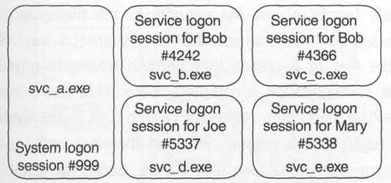
Figure 4.3. Service logon sessions

Although I'll save the details for Chapter 9, I should mention that a COM server designed to run as a distinguished principal runs in a distinct daemon logon session just as a service would. The difference in this case is that the COM Service Control Manager (SCM) is the one that launches COM servers. Whereas the System SCM establishes a service logon for a service, the COM SCM establishes a batch logon for a COM server. The minor differences between these two logon types are discussed later in this chapter, but from a practical standpoint, you can look at both of these logon types as simply vanilla daemon logon sessions, they are so similar. The fact that there are two types of daemon logon sessions is simply an unfortunate historical footnote in the evolution of Windows.

Network Logon Sessions
Now that AlicesMachine has booted, the System logon session is happily running, and some services and COM servers have started in service- and batch-style logon sessions, respectively, AlicesMachine is a fully functional node on the network.
Suppose that Sarah, the administrator of the Foo domain (where AlicesMachine is a member) wishes to update some software on AlicesMachine. Before the operating system on AlicesMachine will allow Sarah to do anything, Sarah must authenticate herself, thus establishing a logon session on AlicesMachine. The question is, does Sarah have to physically walk over to Alice's office to get the work done? Thankfully, the answer is no. Sarah can simply authenticate herself across the network to the file system redirector on AlicesMachine and connect to an administrative share (C$, say). Sarah can now simply copy the files to AlicesMachine without having to physically visit the machine. After authentication is complete, Sarah now has a logon session on AlicesMachine; the file system redirector (which runs in the System logon session) holds a token to this session, and can therefore verify that Sarah does indeed have permission to upload files via C$. Sarah has established what is known as a network logon on AlicesMachine.
What if Sarah wanted to make a secure RPC or COM call across the network to AlicesMachine? A similar procedure takes place in this case as well: Sarah authenticates herself across the network, thus establishing a network logon session on AlicesMachine. The COM or RPC server can discover Sarah's identity and authorization attributes by looking at the resulting token.

Interactive Logon Sessions
The System logon session hosts a process known as Winlogon (winlogon .exe), which acts as the gateway for interactive users. When Alice walks up to AlicesMachine in the morning and presses Control-Alt-Delete, Winlogon displays a user interface to collect Alice's credentials. More specifically, a pluggable DLL known as the GINA (Graphical Identification and Authentication) hosts all the user interface components displayed from the Winlogon process. Take a peek at the resources inside msgina.dll (this is the default GINA DLL that lives in the %SYSTEMROOT%\system32 directory) using Visual C++ (or whatever tool you prefer), and you'll see lots of familiar dialogs.
Just as the System SCM creates logon sessions for daemons, Winlogon creates logon sessions for humans. After Alice presents her credentials, the Winlogon process hands these credentials off to the LSA, which verifies Alice's identity and produces a logon session and a token for her. Winlogon then looks in the registry for a named value shell under the following registry key:

HKLM\Software\Microsoft\Windows NT\CurrentVersion\Winlogon
@Shell="explorer.exe"

Winlogon launches this application, starting the process in Alice's new logon session.
When Alice uses the Start menu to launch an application (or any of the myriad other ways she can launch applications via Explorer), the shell ultimately calls CreateProcess, which starts a new process running in the same logon session. Figure 4.4 shows an example of the logon sessions and a few processes to give you a feel for how the system looks at this point. When Alice chooses to log off, the operating system will tear down each process running in her interactive logon session, and then the logon session itself will be torn down.

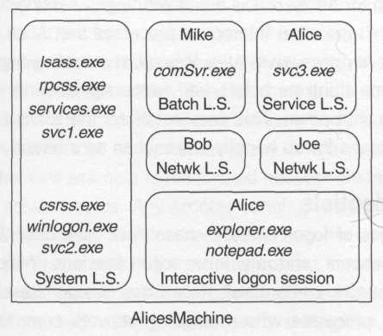
Figure 4.4.A typical collection of logon sessions

So what happens if Alice chooses to configure a service to run using her own account (DOMA\Alice)? Recall what the System SCM does when it is asked to start a service running as a distinguished principal. It asks the LSA to authenticate the principal (using a stashed password), which results in a brand-new logon session for Alice. This is a different logon session from the one hosting Explorer and all the other interactive processes that Alice has launched via Explorer. So what happens when Alice logs off, terminating her interactive logon session? The same thing as before – all processes running in the interactive logon session are shut down. This does not affect the service running as Alice; that service continues to run happily, even when no interactive user is present.

Network Credentials
Five different types of logon sessions have now been described: the System, service, batch, network, and interactive logon sessions. Which of these logon sessions have network credentials? Recall that a logon session with network credentials hosts processes whose outgoing network communications can be authenticated. The only sessions that might not have network credentials are the System logon session (as discussed earlier in this chapter) and virtually all network logon sessions.
Network logon sessions are designed to represent remote clients; to protect those clients, their credentials are not normally delegated to the servers with which they authenticate. It would be very dangerous indeed if Sarah (the domain administrator) were to allow her credentials to propagate to each server she contacted during the day, because if a bad guy compromised any of these servers, he or she could easily masquerade as Sarah on the network and do tons of damage throughout the domain. After reading Chapter 7, you'll have a much better understanding of how this works.

Tokens
All this discussion of logon sessions is very important, but the majority of programmers will never get their hands on one directly. Instead, developers see logon sessions through a level of indirection known as a token. Chapter 2 introduced the relationship of tokens to logon sessions and postulated that a token was just part of the surface area of a logon session – a level of indirection that allows localized customization of the characteristics of a logon session on a per-process basis. I like this view of the world because it emphasizes the importance of thinking about the logon session behind the token.
Before moving on, I'd like to specifically define a term that I've been using rather loosely so far: security context. Security context is a collection of out-of-band settings that affect the security-related behavior of a process or thread. It's just a convenient name that encapsulates many of the concepts we've been talking about so far. One example is the cached network credentials that Alice's interactive logon session holds. Any process running within this logon session can access remote resources as Alice because its security context has network credentials. This particular part of the security context comes directly from the logon session, but tokens add a set of customizable attributes that a process can modify to suit its needs (the default security settings for new objects was an example used in Chapter 2). Therefore, the security context of a particular process is determined by the token associated with that process plus the logon session that the token represents. Security context is an abstract idea, and the term will be used when discussing security settings in a token or logon session in situations in which it's not important to distinguish exactly where the setting is stored.

Anatomy of a Token
Tokens contain several settings that are categorized in Figure 4.5. Each bit of information shown in the figure is accessible via a couple of APIs that are discussed shortly.

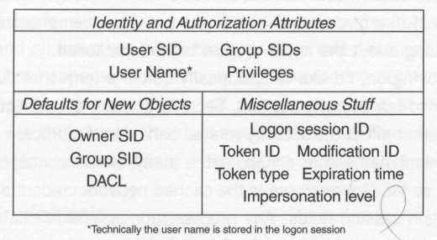

Figure 4.5. Anatomy of a token

Identity and Authorization Attributes
The first category, identity and authorization attributes, constitutes the most influential characteristics of a security context. The user SID is the read-only SID of the principal whom the logon session represents. This is the principal whose name will show up in the audit log when code executing in this security context opens secure resources such as files and registry keys.
The user name is a cached string representation of the principal's name. Although you can discover this name by brute force (just pass the user SID as input to the LookupAccountSid function), this may be quite expensive (think several network round-trips) if the account is managed on a remote domain controller. The GetUserName(Ex) function exists to extract the value that was cached when the logon session was created; therefore, it's preferable to use this function as opposed to mapping the SID to a name at runtime.
The group SID list is a fixed collection of SIDs for all groups and aliases that have been assigned either directly or indirectly to the principal indicated by the user SID. Each group SID in the list is accompanied by a set of flags that determines how the group can be used and how it will affect the security context. (Each group SID can either represent a group or an alias, but the distinction is unimportant for this discussion.) Here's a description of what these flags mean.

- se_group_enabled is a read-write flag indicating that the group should be considered when access checks are performed using this token. If this bit is cleared for a particular group, the security context would act as if it were not a member of that group. Because an object may not only grant access to a group SID but also deny access to a group SID, this isn't a terribly useful feature. As it stands, it would be a rather subtle security hole if groups in a token could be arbitrarily disabled. For instance, if Alice explicitly denies the Accountants group access to a file on AlicesMachine, a smart accountant with an interactive logon session on AlicesMachine could simply write code to disable this group SID in his or her token before accessing the file. This flag is set in all group SIDs that I've ever seen in a token.
- se_group_enabled_by_default is a read-only flag that means just what it says. Once again, in all the tokens that I've ever looked at, I've never seen a group SID with this bit clear.
- se_group_mandatory is a read-only flag indicating that the se_group_enabled flag may not be cleared. Virtually all groups in any token you'll ever see have this flag set, most likely because of the issue discussed earlier. The only scenario I've encountered in which this flag is cleared is on the Administrators alias in any token for the System logon session. This makes sense because code running in the System logon session is part of the TCB and can ultimately do whatever the heck it needs to do, regardless of security constraints. This flag seals the potential security hole exposed by se_group_enabled, and effectively renders that flag read-only for tokens other than those for the system logon session part of the TCB.
- se_group_owner is a read-only flag indicating that this group can potentially act as the owner SID in an object's security descriptor (detailed discussion of this concept is deferred until Chapter 6). In practice, this flag is always clear, except in one notable case: The Administrator alias (if present) will have this flag set.
- se_group_logon_id is a read-only flag indicating that this group is actually not a group at all, but rather is a SID that identifies the logon session that this token represents. This allows a DACL to grant or deny access not only to a particular principal, but also to a particular instance of that principal.
- se_group_use_for_deny_only is a read-only flag indicating that this group SID will only be used for comparisons with negative DACL entries, not positive ones (see Chapter 6 for details). Having a group with this attribute set can never help you get access to an object; it can only be used to deny access. This is a Windows 2000 feature. Tokens that contain deny-only group SIDs are known as restricted tokens (I'll talk about these later in the chapter).

The privilege list is the collection of all privileges assigned to the principal represented by the user SID. These privileges may be assigned directly to the principal or indirectly via a group or alias; see Chapter 1 for a detailed discussion of how privileges are populated in the token.
Each privilege in the token is identified by a LUID as opposed to a string, and there are APIs (demonstrated shortly) to map the LUIDs in the privilege list to well-known privilege names and localized, administrator-friendly description strings. Having LUIDs in the token as opposed to strings is beneficial for a number of reasons:

- Programming against fixed-length data structures is easier than dealing with variable-length strings.
- Storing LUIDs in the token saves space.
- The system caches the LUID mappings, and it's more time efficient to compare LUIDs with one another as opposed to comparing variable-length strings.
- The added complexity helps us keep our high-paying jobs as security-savvy developers.

Just as each group SID is annotated with a set of flags, so each privilege in the token is annotated with a couple of flags.

- se_privilege_enabled is a read-write flag that determines whether the privilege is in effect in this security context. Most privileges are disabled by default, so this bit will normally be clear except in a few rare cases that are enumerated later (see Figure 4.6).
- se_privilege_enabled_by_default is a read-only flag that means just what it says. In the average token, this bit is clear in all privileges except SeChangeNotifyPrivilege ("Bypass traverse checking"), which is always enabled by default if it is present in the token. In any token for the System logon session, several privileges are enabled by default (see Figure 4.6 for an example).

Defaults for New Objects
Chapter 3 introduced the notion of a security descriptor, a data structure that encapsulates the security settings for an individual object such as a mutex, file, or registry key. When you create a new mutex, for instance, you have the chance to specify exactly what you'd like its security descriptor to look like via the well-loved lpsecurity_attributes parameter to CreateMutex. Even if you broke down and actually passed a security descriptor here, it'd be nice if you only had to populate that security descriptor with the information that you cared about. For instance, the main reason you'd bother passing something other than NULL is to provide a customized DACL that grants very particular access permissions to certain individuals and denies others. However, a security descriptor has much more in it than just a DACL. Do you also have to specify the owner and primary group and SACL? The answer is a resounding no. Any information you neglect to pass can simply be extracted from default values in your token. The default owner SID is a read-write value that will be used to populate the owner SID in the security descriptors of new objects you create where you don't explicitly specify an owner SID.
Similarly, the default primary group SID is a read-write value that will be used to populate the primary group SID in those security descriptors. This is a godsend since few people care about the POSIX subsystem in Windows.
Finally, the default DACL is a read-write value that will be used in certain situations to generate a reasonable DACL for the security descriptors of new objects you create where you don't explicitly specify a DACL. This mechanism is discussed further in Chapter 6.
Note the distinct lack of a default SACL field. SACLs are applied at the system administrator's discretion; random principals are not allowed to determine the auditing policy on a given machine.
What's great about these default attributes is that if you pass NULL for the lpsecurity_attributes parameter to CreateMutex and friends, the system will grab all this default information from your token and apply it automatically for you. This means you have one-stop shopping to adjust the DACL applied to objects you create in a particular security context.

Miscellaneous Stuff
The following attributes make up the rest of the documented token settings.

- The logon session LUID is the read-only 64-bit identifier for the logon session that this token represents. Many tokens can be associated with a single logon session. (Remember that each process has its own distinct token, and many processes can run within the context of a single logon session.)
- The token LUID is a read-only 64-bit identifier for the token object itself, and is simply a unique identifier that allows you to perform an identity test between two token handles.
- The modification LUID is a read-only 64-bit identifier that changes whenever any information in the token is adjusted. (For example, if you call into a DLL and it enables and disables a privilege, you can detect it by tracking this value.) The token and modification LUIDs are designed to be used in concert when implementing a performance-tuned access control scheme: Prior to performing a full-blown access check, the server consults a cached dictionary to look for the token LUID for the client making the request. A cache hit results in a record containing a modification LUID and the resulting permissions granted from an earlier access check. Assuming that the modification LUID in the client's token still matches the one in the cache, and that the DACL on the object in question hasn't changed, the server can safely skip the access check because nothing has changed. A cache miss means the server would have to perform the access check, caching the results, of course.
- The expiration time field never has been (and probably never will be) used for anything. Tokens do not expire (even on Windows 2000).
- The token type is a read-only value that indicates (for historical reasons) whether this is a primary token or an impersonation token.
- The impersonation level is a read-only value that indicates the level of trust the system places in your usage of this token. More information is provided about this and the token type later in the chapter (in the discussion of impersonation).

Peering into a Token
As an example, Figure 4.6 shows some of the more interesting contents of a token for the System logon session on Windows 2000 (asterisks mark the elements that are not present in earlier versions of Windows NT), placed side by side with a token for Alice@foo.com, a normal, nonadministrative principal.

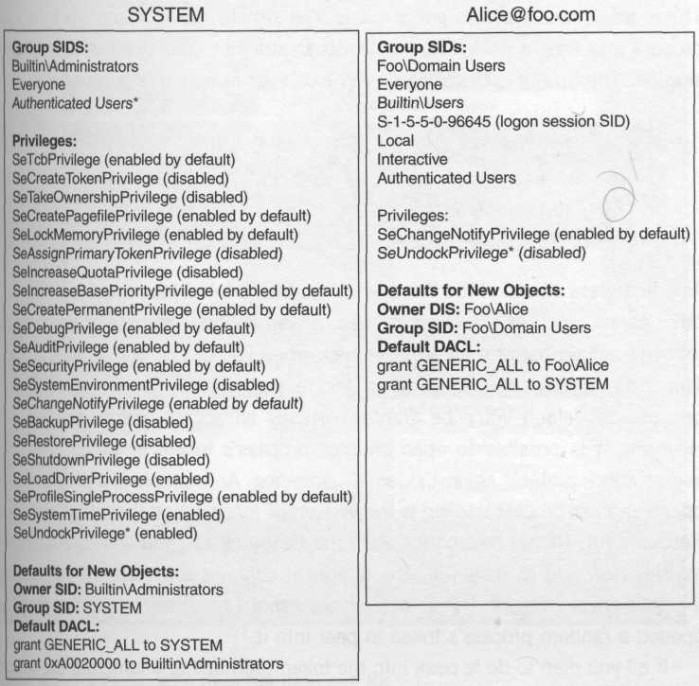
Figure 4.6. Tokens for SYSTEM and Alice@foo.com

Getting a Process Token
There are several ways to get a token. The simplest is to reach up into your process and take a peek at the token that attaches your process to its logon session. The OpenProcessToken API exists for exactly this purpose.

BOOL OpenProcessToken(
HANDLE ProcessHandle, // in, handle or pseudohandle
DWORD DesiredAccess, // in
PHANDLE TokenHandle); // out

As a first-class citizen of the Windows executive, a token is secured just like any other object (such as a process, thread, or semaphore), and the operating system will always perform an access check when you call OpenProcessToken. This isn't terribly interesting when you're getting your own process token, because by default you'll be granted virtually all access permissions to it. However, it is possible to open another process's token, in which case this access check protects against external tampering. An example of a program that opens another process's token is the version of pview.exe that ships with the Resource Kit. (If you haven't installed the Resource Kit, you should stop reading this now and go install it – the utilities it contains are tremendously useful for developers.) Figure 4.7 shows a screenshot of pview.exe in which I've opened a random process's token to peer into it.
If all you plan to do is peek into the token (perhaps to enumerate the group SIDs), you'll only need to ask for token_query permissions, and here's the classic code you'll quickly get used to writing:

HANDLE htok;
OpenProcessToken(GetCurrentProcess(), TOKEN_QUERY, &htok);

// do something with the token,
// then close it when you're done
CloseHandle(htok);

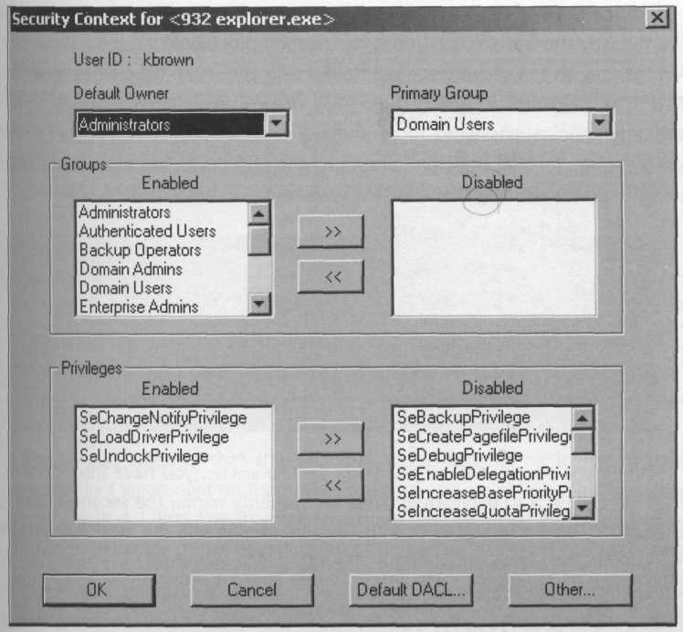
Figure 4.7. PVIEW.EXE from the Resource kit.

Creating New Logon Sessions
Another way to get a token is to create a new logon session. Later in this chapter (when I cover impersonation), I'll talk about how you can get a token by authenticating a principal who has sent you a request over the network (examples of secure network protocols you might use to do this include named pipes, RPC, and COM).
You can also choose to create a brand-new logon session on the fly (just like the way the System SCM does for daemon processes) via the LogonUser API, as long as the security context from which you make the call is part of the TCB. The LogonUser API is quite easy to use, allowing you to pass in an authority/principal/password tuple and get back a token representing a new logon session for that principal, assuming the LSA could successfully authenticate the principal using the specified password.

BOOL LogonUser(
LPTSTR lpszUsername, // in, principal
LPTSTR lpszDomain, // in, authority
LPTSTR ipszPassword, // in
DWORD dwLogonType, // in
DWORD dwLogonProvider, // in, optional
PHANDLE phToken); // out

When you specify the authority via lpszDomain, you have three choices, The first choice is to explicitly provide an authority name; the second choice is to pass ".", which indicates that the system should use the local authority (if the machine is a domain controller, then this indicates that lpszUsername is a domain account; otherwise, LogonUser looks for a matching local account), Finally, if you pass NULL for lpszDomain, the system searches for the closest authority (including the local authority) with a matching account name. This is the documented behavior, but in earlier versions of Windows NT, passing NULL for lpszDomain erroneously results in an access violation, so you will probably want to avoid this third option unless you know for certain your code will only run on Windows 2000 or greater.
You should always pass 0 for the optional dwLogonProvider parameter so that your code won't be tied to a single version of Windows NT (there is one exception to this rule that I'll discuss later in the chapter). If successful, LogonUser drops a handle to the new token wherever you point phToken.
The dwLogonType parameter has been purposely left for last, because it's the most interesting of the bunch. You are allowed to create four fundamental types of logon sessions: interactive, batch, service, and network, each of which has different semantics. The first important point to note about each of these logon types is that the principal you're attempting to log in must have a distinct logon right on the machine where you are establishing the logon session. Table 4.1 lists the manifest constants that indicate the type of logon you desire, the value of the constant, and the friendly names of the associated logon rights. If the subject hasn't been granted the corresponding logon right, the LSA will deny the logon request, and GetLastError will answer error_logon_type_not_granted. The appendix shows how to grant these rights programmatically.

Table 4.1. Fundamental logon types and rights
Manifest Constant | Value | Logon Rights
logon32_logon_interactive | 2 | Log on locally  Deny log on locally
logon32_logon_batch | 4 | Log on as a batch job  Deny log on as a batch job
logon32_logon_service | 5 | Log on as a service  Deny log on as a service
logon32_logon_network | 3 | Access this computer from network  Deny access this computer from network

By far the best way to detect problems like this during development is to turn on auditing of logon and logoff events. You can do this via the Group Policy snap-in in Windows 2000, or via User Manager in earlier versions of Windows NT. Auditing is an important debugging tool for the traditional systems-level developer; the screenshots in Figure 4.8 show how to enable it in both versions of Windows.

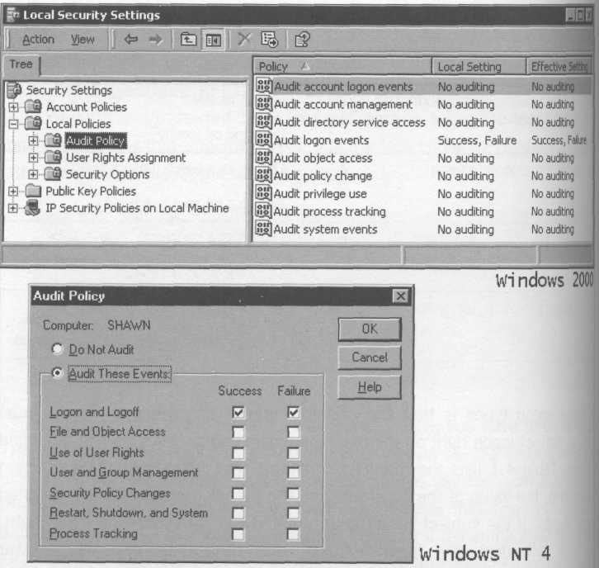
Figure 4.8. Enabling auditing of logon and logoff events

Each time a new logon session is created or destroyed, an entry is placed in the security event log that shows the time, authority and principal name, and the type of login (via the corresponding number shown in Table 4.1). The beauty of auditing is that when a logon request fails, the entry in the log will usually tell you exactly what went wrong. Classic examples include the following:

- You forgot to turn off the "User Must Change Password at Next Logon option when you added the account.
- The account may be disabled.
- The principal may not have the corresponding logon right on the machine where you're attempting to establish the logon session.

Go turn on the auditing feature on the machines you use for development if you haven't done it yet. As long as you're not calling LogonUser in a tight loop, or authenticating network clients right and left, it won't hurt your application's performance in any noticeable way, and in the lab, you'll benefit immensely during testing.
By default, all principals are granted the right to a network-style logon, but only specific principals designed to sponsor daemon processes are granted the right to establish a batch or service logon (recall that the COM SCM uses a batch-style logon, whereas the System SCM uses a service-style logon). If you call CreateService to install a service configured to run as a distinguished principal, the System SCM will eventually need to create a logon session for that principal. The CreateService API doesn't grant the service logon right automatically, so if you neglect to grant this right on the machine where the service is hosted, the SCM won't be able to establish the required logon session, and the service will fail to start. Of course, if you use tools such as the Windows 2000 Services snap-in or the Services applet in the Windows NT Control Panel to configure a service to run as a distinguished principal, these tools will grant the service logon right automatically (and they'll tell you so with a dialog box). Regardless, a well-written install program should be coded to configure the services it installs automatically (see the appendix for a discussion of programmatically granting logon rights and privileges).
When you establish an interactive logon on a machine that is a member of a domain, once the LSA successfully authenticates the principal, it caches enough information on disk to allow local logon in case the machine becomes disconnected from the network (and thus cannot contact its authority for help authenticating domain principals). According to my own tests, LogonUser normally takes about 1 millisecond to authenticate a local account, and on the order of 10 milliseconds for a domain account (with a fast, lightly loaded network with a domain controller planted on the same subnet). LogonUser is, well, blazingly fast. However, an interactive-style logon, likely due to the added disk activity, takes on the order of 600 milliseconds. Among the types of logon sessions, the network-style logon stands out as unique in two ways. First, in this case LogonUser creates what is known as an impersonation token, as opposed to the primary token created for the other types of logon sessions. The distinction between these two types of tokens is a historical artifact that is discussed shortly. The second difference is much more important: The logon session produced by LogonUser for a network-style logon does not have network credentials (although Windows 2000 provides a variation on this theme as I'll discuss shortly).
Another logon type that was only recently documented for use with LogonUser is used by the GINA DLL to unlock the local workstation (this also generates an audit log entry if auditing of logon events is enabled): logon32_logon_unlock. I mention this for completeness; outside of the GINA, I don't see a use for this type of logon.
Windows 2000 added a couple of other interesting logon types that are simply variations on the four fundamental logon types that I've already introduced. The first is a slight modification to the NETWORK logon session that causes it to cache the credentials specified to LogonUser (thus the resulting logon session will have network credentials); this is logon32_logon_network_cleartext.
The other flag is really twisted and quite a bit of fun: logon32_logon_new_credentials. This flag causes LogonUser to duplicate the token of the caller but give an alternate set of network credentials, specifically the credentials specified to LogonUser. Thus the new security context will be represented locally via the original token, but on the network, it'll be authenticated using the new credentials. As I'll discuss in Chapter 5, the RunAs service uses this trick in certain cases. In order to successfully use this logon type, you must specify logon32_provider_winnt50 for the dwLogonProvider argument to LogonUser.

Identifying Logon Sessions at Runtime
It was mentioned earlier that logon sessions are identified by a 64-bit number (a LUID). This value can be discovered at runtime by calling GetTokenInformation and requesting the TokenStatistics class of information. Well, it turns out that you can also grant or deny access to logon sessions either individually or based on the type of logon session. Each token produced for a particular logon session generally has two special SIDs added to the list of group SIDs for exactly this purpose.
The first SID is a well-known SID that represents the type of logon session in use: INTERACTIVE, NETWORK, BATCH, or SERVICE. You've probably seen some of these in ACL editors. For instance, when you go to a file and grant access to INTERACTIVE, you are granting access to anyone who has established an interactive-style logon session on the machine. When you deny access to NETWORK, you are denying access to anyone who has established a network-style logon. Because all secure transports use network-style logons to represent remote principals making requests via the network, it's clear how useful these two SIDs can be. Distinguishing between interactive, batch, and service logons is less interesting, although Windows 2000 does list the batch and service SIDs in its ACL editors for completeness.
The other special group SID is created on the fly, and is denoted in the token with the se_group_logon_id flag. This SID takes the form S-1-5-5-X-Y, where X and Y are the high- and low-order parts of a LUID that uniquely identifies the logon session.
Why on earth would you want such a thing? It gives you a very fine-grained model of access control, because you can now grant access not just to Alice, say, but to a particular instance of Alice. This fine-grained model is used by convention with the interactive window station to grant or deny access to individual logon sessions, as you'll see later in Chapter 5.
The System logon session has neither of these two special SIDs. It is not an interactive-style logon. It is not a batch-, service-, or network-style logon either. It just exists implicitly whenever the operating system is alive. It has no logon session SID, because there will only ever be a single instance of the System logon session, and you can always identify it (to grant or deny access) via the SYSTEM SID, S-1-5-18.

Managing Tokens
Often you'll need to peer into a token at runtime. The GetTokenInformation API provides access to all the data stored in the token.

BOOL GetTokenInformation(
HANDLE TokenHandle, // in
TOKEN_INFORMATION_CLASS TokenInformationClass, // in
LPVOID TokenInformation, // out
DWORD TokenInformationLength, // in
PDWORD ReturnLength); // out

For instance, to retrieve the list of group SIDs along with their attributes, you'd allocate a block of memory, pass a pointer to that block via the TokenInformation parameter, specify the size of the memory block in bytes via the TokenlnformationLength parameter, and specify TokenGroups for the TokenlnformationClass parameter. As long as you guessed the buffer size correctly, the function will return a nonzero value indicating that it filled your buffer with a variable-length token_groups data structure, whose format in memory is shown in Figure 4.9.

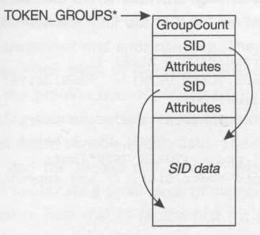
Figure 4.9. The TOKEN_GROUPS data structure.

If you didn't guess the buffer size correctly (or if you passed 0 for the Tokenlnformation and TokenlnformationLength parameters, indicating that you do not bend spoons with your mind for a living), the system will tell you how large a buffer you need via the ReturnLength parameter, and you then make a second call to this function passing a correctly sized buffer. As Figure 4.9 indicates, even though the token_groups data structure contains pointers to SIDs that are variable length by nature, all this information is stuffed into that single block of memory that you allocated.
Generally speaking, you'll have no problem figuring out how to extract the information you need from a token via GetTokenInformation. The documentation for the API lists all the classes of information you can retrieve and the corresponding data structure that the function will return. For instance, to retrieve the user SID, you'd specify the TokenUser class of information, and the function would return a token_user structure. It's pretty straightforward.
There are a few tricky points to note, however. Many of the elements I included in the Miscellaneous Stuff category (a few sections back) must be retrieved as a bundle via the TokenStatistics class of information. In the token_statistics structure, there is a LUID with a somewhat confusing name: AuthenticationId. This is simply the logon session LUID. The DynamicCharged field in token_statistics specifies how many bytes the system has reserved in the token for storing the default settings for new objects (the default owner and primary group SIDs and the default DACL). From what I can tell, this value is always fixed at 500 bytes. The DynamicAvailable field specifies how many of these bytes are free, with the majority of the space being occupied by the default DACL.
The following code fragment shows an example of using GetTokenInformation to print out the user SID for a given token.

void printUserSid(HANDLE htok)
{
BYTE buf[sizeof(TOKEN_USER) + maxSidSize];
DWORD cb = sizeof buf;
if (GetTokenInformation(htok, TokenUser, buf, cb, &cb))
{
TOKEN_USER* ptu = (TOKEN_USER*)buf;
printSid(ptu->User.Sid); // see appendix
}
}

You can update the read-write settings in the token via three functions: SetTokenInformation, AdjustTokenGroups, and AdjustTokenPrivileges. The first of these functions is used to adjust the default settings for new objects:

BOOL SetTokenInformation (
HANDLE TokenHandle, // in
TOKEN_INFORMATION_CLASS TokenInformationClass, // in
LPVOID TokenInformation, // out
DWORD TokenInformationLength); // out

The usage of this function is very straightforward. Just specify the class of information you want to update (ТокепОwnег, TokenPrimaryGroup, or TokenDefaultDacl), and pass in the corresponding data structure.
AdjustTokenGroups is useless in virtually all scenarios because groups normally cannot be enabled or disabled using this mechanism. (The one esoteric exception was mentioned earlier – a process running in the System logon session can adjust the groups in its token to disable the Administrators group SID.) Aside from AdjustTokenPrivileges, which is discussed shortly, this is the extent to which you can change the settings in a token. As you can see, the vast majority of information in a token is immutable.

Memory Allocation and Error Handling Strategies
Let's take a short interlude and talk about how the Windows security APIs deal with memory management and error handling. They generally follow one of two models. The approach taken by GetTokenInformation is consistent throughout most of the pre-Windows NT 4.0 security APIs. The caller is responsible for allocating memory, which means the caller always makes two calls to functions that return variable-length data. The first call retrieves the length of the buffer, and the second call actually gets the data. A typical optimization would be to allocate a small block of memory on the stack via an automatic variable and to pass that in on the first try, just in case the data returned is small.
When Windows NT 4.0 was released, a whole new set of APIs was documented that, for better or worse, used a completely reversed scheme for memory management. Rather than forcing the caller to guess the buffer size, these functions allocate memory via LocalAlloc, so you are responsible for freeing it via LocalFree. This is similar to the model that COM programmers are familiar with, and it's convenient because you only need to make a single call to the API. The compiler can easily enforce the differences between these two models, because in the first model, you must pass a pointer to a block of memory, whereas in the second model, you must pass a pointer to a pointer variable. The error handling story isn't quite so pretty, though.
The earlier APIs use the traditional mechanism of error handling by which each function returns a bool to indicate success or failure, and by calling GetLastError you can retrieve more details. This means you look for a nonzero value to indicate success.
The APIs introduced in Windows NT 4.0 use the same style of error handling popularized by COM and the registry APIs (the registry was originally introduced in Windows 3.1 to support COM). These newer APIs return an error code directly, as opposed to a bool. This means you don't have to call GetLastError because the function has already handed you all the information you need via the return value. In this case, you look for a zero value to indicate success. Every programmer working with the security APIs gets bitten by this little gotcha eventually, because he or she ends up using the older APIs in concert with the newer ones at some point.
Just to mix things up a bit, Microsoft added some new APIs in Windows 2000 (ConvertSidToStringSid is one example) that use the old-style error handling model and the new-style memory allocation model. I once postulated that the Windows API is not inconsistent; rather, it's built from islands of consistency. These are just particularly small islands.

Using Privileges
Privileges are interesting beasts. Not only are they cached in a token using a LUID mapping that isn't guaranteed to be unique across machine reboots, but they are also almost invariably disabled by default; to use a privilege you must first enable it.
Let's stop and review the big picture. When an administrator grants Alice a privilege on AlicesMachine, all new logon sessions she establishes there will include this privilege as an authorization attribute, and all (nonrestricted) tokens will hold this privilege. This generally does not mean that a process running in Alice's logon session can use this privilege accidentally. Programs usually need to be deliberate about their use of privileges, manually enabling them and disabling them as appropriate. For instance, as an administrator, by default you are granted SeDebugPrivilege, which means that code running in your logon session is allowed to open up any process on the machine for all permissions, (This is convenient if you want to kill a daemon that has hung; in this case you must open the process handle for process_terminate access in order to call TerminateProcess.) However, lots of folks have discovered that Task Manager often reports error_access_denied when asked to kill a daemon process, even when running with administrative privileges. When run by an administrator, Task Manager's token includes SeDebugPrivilege, but it's not enabled, and Task Manager doesn't enable it (to try to keep you from hurting yourself). If you want Task Manager to be able to kill any process on your machine, you can use a tool such as pview.exe to enable SeDebugPrivilege in its process token. kill.exe, as an example, enables this privilege to perform its work (both kill.exe and pview.exe ship with the Resource Kit).
Many developers have actually exercised privileges without explicitly writing code to enable them. Sometimes a function exposed by the Windows API will temporarily enable a privilege in order to perform its job (and then will restore it to its previous value). Microsoft is really good about documenting the privileges on which any given API relies, and whether or not it'll automatically enable the privilege for you, but you have to be aware that if one of the required privileges isn't even present in your token to begin with, the function is going to fail when it attempts to enable that privilege.
Recall how privileges get injected into a token in the first place. At authentication time, the LSA constructs a token, populates the user and group SIDs, and then takes the union of all privileges assigned to any of these SIDs and dumps those privileges into the token. That's it. You cannot later inject additional privileges into an existing token. To grant a privilege, you must add a privilege assignment either directly to the principal's account or to a group or alias that you can then assign to the principal.
Once a logon session is created, any (nonrestricted) tokens it exposes contain a snapshot of the authorization attributes for the principal that were captured at the beginning of the session (in other words, at authentication time). This implies that granting a privilege (or a group membership, for that matter) to a principal has absolutely no effect on existing logon sessions. After granting a privilege, you may want to "refresh" by reauthenticating and creating a new logon session. The token you get back from this new logon session will have the updated information.
Refreshing means closing all processes currently running within the stale logon session, and restarting them in the new logon session. For an interactive logon session, this can be accomplished by logging out and logging back in (this does not mean rebooting Windows, of course). For a daemon process managed by the System or COM SCM, this means shutting down and reactivating the service or COM server.
Each privilege is uniquely identified by a short string (the programmatic name), such as SeTcbPrivilege and SeBackupPrivilege. These names are defined via manifest constants (such as se_tcb_name, se_backup_name, etc.) in the winnt.h header file. Each privilege also has a slightly longer (and localized) display name that administrators are familiar with, such as "Act as part of the operating system", "Back up files and directories", and so forth. Sometimes the display names don't look much like the programmatic names (the classic example is SeChangeNotifyPrivilege, whose display name is "Bypass traverse checking"); Table A.4 in the appendix will help you find your way through the jungle.
As mentioned earlier, many functions automatically enable privileges. Here are a few examples: LogonUser requires SeTcbPrivilege. CreateProcessAsUser requires two privileges: SelncreaseQuotaPrivilege and SeAssignPrimaryTokenPrivilege. GetSecurityInfo requires the SeSecurityPrivilege, but only if you request the SACL of an object.
There are other scenarios in which you will need to manually enable a privilege in order to use it. One classic example is backing up a set of files to which you have not been explicitly granted access. The SeBackupPrivilege exists to grant overarching backup rights to trusted accounts that are normally used for running backup software. This allows an administrator to make a global policy decision as opposed to having to muck with the DACLs of each individual file that needs to be backed up. To exercise the SeBackupPrivilege (assuming it's already in your token), you need to adjust your token to enable the privilege: when you open the file, you specify a special flag that indicates to the file system that your intention is to perform a backup operation. The key function you'll call is AdjustTokenPrivileges:

BOOL AdjustTokenPrivileges(
HANDLE TokenHandle, // in
BOOL DisableAllPrivileges, // in
PTOKEN_PRIVILEGES NewState, // in, optional
DWORD BufferLength, // in, optional
PTOKEN_PRIVILEGES PreviousState, // out, optional
PDWORD ReturnLength); // out, optional

The TokenHandle parameter specifies a token that has been opened for at least token_adjust_privileges permissions. If you want to use the PreviousState parameter to retrieve the old state of whatever privileges you're modifying, TokenHandle will also require token_query permissions. Passing true for DisableAllPrivileges causes the function to ignore the NewState and BufferLength parameters entirely; this disables all privileges in the token, including ones that are enabled by default, such as SeChangeNotifyPrivilege.
The NewState parameter (and its corresponding byte-length indicator, BufferLength) is the core of this API. The token_privileges structure is simply a counted array of pairs; each pair contains a LUID representing the privilege you'd like to tweak and the flags you want to change in the token (the only flag you're allowed to adjust is se_privilege_enabled). Because this is a variable-length data structure, if you want to enable more than one privilege in a single shot, you have to do some dynamic memory allocation and some nasty casts. In practice, however, you'll usually only be adjusting a single privilege at a time, which is quite straightforward because the data structure is already declared with one entry in the array.
A convenient way to approach error handling is to simply attempt to enable the privilege you require via AdjustTokenPrivileges, and check to see if it worked. If the token doesn't have the privilege cached inside it, AdjustTokenPrivileges will indicate this, but not by returning false; you must instead call GetLastError and look for the distinguished error code error_not_all_assigned. This subtlety is a nasty one because it'll trip you up only in failure conditions.
Given a privilege's programmatic name (such as SeBackupPrivilege), you'll need to look up its local LUID mapping. (The mappings can change across reboots, so don't hardcode these values into your application.) To do this, you'll need to use the LookupPrivilegeValue API:

BOOL LookupPrivilegeValue(
LPCTSTR lpSystemName, // in, optional, machine name
LPCTSTR lpName, // in, programmatic name
PLUID lpLuid); // out, the LUID mapping

If for some esoteric reason you needed to obtain the LUID mapping for a privilege on another machine, this function would theoretically be able to obtain it for you if you pass a non-NULL lpSystemName, although I can't think of any reason for needing this functionality. In practice, you'll pass NULL for this first parameter and pass the programmatic name via lpName, and the function will look up the LUID mapping and dump it wherever you point lpLuid, Generally you'll drop this mapping either into a global variable for later use or directly into a token_privileges structure, as in the following code. The following code snippets demonstrate a very common set of helper functions for enabling and restoring privileges that every Windows security developer ends up writing eventually.

bool enablePrivilege(
HANDLE htok,
const wchar_t* pszPriv,
bool bEnable,
TOKEN_PRIVILEGES& tpOld)
{
// fill out the request form :-)
TOKEN_PRIVILEGES tp;
tp.PrivilegeCount = 1;
tp.Privileges[0].Attributes = bEnable ? SE_PRIVILEGE_ENABLED : 0;

if (!LookupPrivilegeValue(0, pszPriv, &tp.Privileges[0].Luid))
return false;

// htok must have been opened with these permissions:
// TOKEN_QUERY (to get the old privileges setting)
// TOKEN_ADJUST_PRIVILEGES (to adjust the privileges)
DWORD cbOld = sizeof(tpOld);

if (!AdjustTokenPrivileges(htok, FALSE, &tp, cbOld, fctpOld, &cbOld))
return false;

// Check GetLastError() to see if the privilege was
// successfully adjusted - don't forget this step!
return (ERROR_NOT_ALL_ASSIGNED != GetLastError());
}

void restorePrivilege(HANDLE htok, TOKEN_PRIVILEGES& tpOld)
{
AdjustTokenPrivileges(htok, FALSE, &tpOld, 0, 0, 0);
}

The following code snippet shows how to use the helper functions from the previous code to exercise SeBackupPrivilege in order to dump the contents of any local file, regardless of its DACL.

void backupFile(const wchar_t* pszFile)
{
// open token with permissions needed to adjust privs
HANDLE htok;
OpenProcessToken(
GetCurrentProcess(),
TOKEN_QUERY | TOKEN_ADJUST_PRIVILEGES,
&htok);

// enable SeBackupPrivilege
TOKEN_PRIVILEGES tpOld;

if (enablePrivilege(htok, SE_BACKUP_NAME, true, tpOld))
{
// open the file with the intention of backing it up
HANDLE hfile = CreateFile(
pszFile, GENERIC_READ, 0, 0, OPEN_EXISTING,
FILE_FLAG_BACKUP_SEMANTICS, 0);

if (INVALID_HANDLE_VALUE != hfile)
{
_dumpFile(hfile) ;
CloseHandle(hfile) ;
}

// clean up when we're done
restorePrivilege(htok, tpOld);
}
else
{
wprintf(
L"Failed to enable SeBackupPrivilege"
L" - do you have this privilege?\n");
}
CloseHandle(htok);
}

Another classic example in which you'll need to enable a privilege is when you call ExitWindowsEx requesting that the operating system shut down or reboot. In this case, you'll exercise SeShutdownPrivilege.
There are a couple of other functions related to privileges that been mentioning. The LookupPrivilegeName function performs the reverse mapping (from LUID to programmatic name) and comes in handy when you're dumping the contents of a token and want to list the privileges cached there. LookupPrivilegeDisplayName maps from the programmatic name to the localized human-readable name that administrators know and love. These functions are similar in usage to LookupPrivilegeValue.

Impersonation
If there were no adjustable settings in a security context (such as privileges and the default DACL), there would be no reason to have tokens; rather, each process could simply have a handle to a logon session where all the data in the security context (groups, etc.) would be stored. But because each process needs to have the capacity to make localized changes to settings in its security context without stepping on other processes in the same logon session, the token was introduced as a level of indirection to solve race conditions between processes. But even with a token per process, isn't there still the potential for race conditions within a single process?
Think about what happens when one thread disables a privilege in the token attached to its process. Doesn't this affect all other threads in the same process, all of which are sharing the single security context afforded by the process token? The answer is most clearly yes. If you are writing a multithreaded application, threads can't just start enabling and disabling privileges willy-nilly or changing the default DACL in your token at uncontrolled times. The most common way of dealing with this issue is to simply punt, and set up your token exactly the way you need it for the duration of the process's life, before you start spawning other threads. This is fine as long as all threads need to run in the same security context. But what if one thread needs something a little different?
When you call CreateThread, or its little brother in the С runtime, _beginthreadex, you've simply created a new schedulable thread of execution within the security context of the process. By default, all threads in a process run within the same security context, specifically, that dictated by the process token. However, there is a function called SetThreadToken that allows a thread to slip into a different security context. This feature is known as impersonation, which is really just a big word for a very simple mechanical feature of the Windows operating system. By giving a thread its own private token, that thread has complete freedom to adjust privileges, the default DACL, and so on, without fear of causing race conditions in other parts of the application. Figure 4.10 shows how this works.

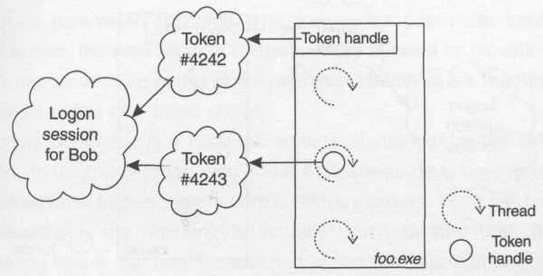
Figure 4.10. Threads tokens solve race conditions

The API for SetThreadToken is quite straightforward:

BOOL SetThreadToken(
PHANDLE Thread, // in, optional (NULL implies this thread)
HANDLE Token); // in, new security context

The following code snippet shows an example of a naive approach to solving a race condition by attempting to give a single thread its own token:

DWORD WINAPI threadProc1(void*)
{
HANDLE htok;
OpenProcessToken(GetCurrentProcess(), TOKEN_IMPERSONATE, &htok);

// the goal is to give this thread its own token
// but does this really do the job?
SetThreadToken(0, htok);

// do work (adjust privileges, etc.)

// by removing the thread token, we revert
// back to the process's security context
SetThreadToken(0, 0);
return 0;
}

As you probably guessed, this code doesn't really do what you want (disregarding the fact that a historical feature of the operating system will cause the first call to SetThreadToken to fail). Figure 4.11 shows what would happen if this code actually ran without errors. In this case, the process and the thread refer to the same physical token object. Duplicating the handle wouldn't help either, because DuplicateHandle doesn't make a copy of the underlying object, which is what you really need here.

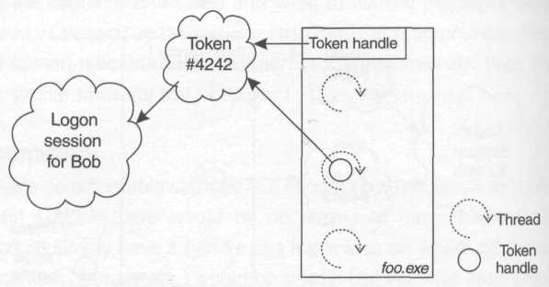
Figure 4.11. A nonsolution

Instead, you need to physically duplicate the token so the thread will have its own copy of all the privilege settings, the default DACL, and so on. A function exists to provide this service:

BOOL DuplicateTokenEx(
HANDLE ExistingToken, // in
DWORD DesiredAccess, // in
LPSECURITY_ATTRIBUTES Attributes, // in, optional
SECURITY_IMPERSONATION_LEVEL ImpLevel, // in
TOKEN_TYPE Type, // in
PHANDLE NewToken); // out

As mentioned earlier, tokens are first-class executive objects, as the Attributes parameter indicates. The ImpLevel parameter specifies the quality of service the new security context will be allowed to provide (more on this later), and NewToken points to the memory location where the function will drop a handle to the new token object.
The Type parameter is a historical artifact. If you look at the definition of the token_type enumeration, you'll find that tokens have been taxonomized into two categories: impersonation versus primary tokens. Don't get hung up on this nomenclature; the meaning is actually much simpler than it sounds. Impersonation tokens can only be attached to threads, and primary tokens can only be attached to processes. That's all it means. The process token obtained earlier via OpenProcessToken was therefore a primary token.
In very early versions of Windows NT (3.x), there were much more severe restrictions on what you could do with a token, depending on where you originally got it from, and hence the token type was introduced to track the intended usage of the token. Because this text assumes you're using Windows NT 4.0 or greater, just think of an impersonation token as a "thread token", and a primary token as a "process token", and use DuplicateTokenEx to convert between the two whenever necessary. Windows NT 4.0 tore down the boundaries between the two by introducing DuplicateTokenEx; the Windows NT 3.x version of this function, DuplicateToken, was hardcoded to only produce impersonation tokens. In fact, now you should be able to see the silly bug that causes the first call to SetThreadToken to fail: the code is attempting to attach a primary token (the one obtained from the process) to a thread (which requires an impersonation token). That's a no-no. To fix both the logical problem and the silly historical problem, here's the corrected code:

DWORD WINAPI threadProc2(void*)
{
HANDLE htok;
OpenProcessToken(GetCurrentProcess(), TOKEN_DUPLICATE, &htok);

// the goal is to give this thread its own token
// so let's duplicate the object and make it happen
HANDLE htokForMyThread;
DupiicateTokenEx(
htok,
TOKEN_ALL_ACCESS,
0,
DEFAULT_IMPERSONATION_LEVEL,
TokenImpersonation, // ask for a thread token
&htokForMyThread);

SetThreadToken(0, htokForMyThread);

// do work (adjust privileges, etc.)
// when finished messing with the token handle, we can
// close it anytime; the thread still references it
CloseHandle(htokForMyThread);

// by removing the thread token, we revert
// back to the process's security context;
// note that this also destroys the token we created
// because the thread no longer references its handle
SetThreadToken(0, 0);
return 0;
}

Note that in order to place a token on a thread, you must have a handle to the token opened with at least token_impersonate permissions, and in order to duplicate a token, you must have a handle to the token opened with at least token_duplicate permissions.
Because giving a thread its own security context to avoid race conditions is such a common practice, a shortcut API performs the duplication and impersonation automatically:

BOOL ImpersonateSelf(SECURITY_IMPERSONATION_LEVEL ImpLevel); //in

The single parameter ImpLevel sets the impersonation level for the new token (I'll talk about what this means in the upcoming section on trust). Using this API can simplify the code tremendously.

DWORD WINAPI threadProc3(void*)
{
ImpersonateSelf(DEFAULT_IMPERSONATION_LEVEL);

// do work (adjust privileges, etc.)

RevertToSelf();
return 0;
}

Note the usage of RevertToSelf, which is effectively the same as a call to SetThreadToken(0,0).

BOOL RevertToSelf();

This is the preferred function to call to remove the thread token when you're done impersonating.

Impersonating Other Logon Sessions
So far the coverage of impersonation has dealt with race conditions, but this usage is rather pedestrian. What gets really interesting is when you take a token from a foreign logon session and attach it to a thread. Now you can have one thread in a security context for Alice and another thread in a security context for Bob, all hosted in a process whose default security context is that of Charlie. One classic example of this technique is in the System logon session on Windows NT 4.0 and earlier, which didn't have network credentials. Suppose you host a process there, but you need it to be able to make authenticated requests on the network (perhaps you need authenticated access to a remote file system). Here's some code that attempts to achieve this feat:

HANDLE openFileAsUserl(
wchar_t* pszAuthority,
wchar_t* pszPrincipal,
wchar_t* pszPassword,
wchar_t* pszFile,
DWORD dwDesiredAccess)
{
// attempt to establish a batch-style logon session
// for the specified principal
HANDLE htok;

if (!LogonUser(
pszPrincipal,
pszAuthority,
pszPassword,
LOGON32_LOGON_BATCH,
0,
&htok))
{
return INVALID_HANDLE_VALUE;
}

// put the token on our thread (does this work?)
if (!SetThreadToken(0, htok)) return INVALID_HANDLE_VALUE;

// open the remote file
HANDLE hfile = CreateFile(
pszFile, dwDesiredAccess,
0, 0, OPEN_EXISTING, 0, 0);

// remove the token from our thread
SetThreadToken(0, 0);
CloseHandle(htok);
return hfile;
}

This code is fine, from a logical standpoint, except for that little gotcha about token types. LogonUser returns a primary token in most cases. (The network-style logon is the exception; in this case, LogonUser returns an impersonation token.) Because the goal here is to obtain a logon session with network credentials, I've chosen to use a batch-style logon, which means I'll get back a primary token, which is not suitable for placing on a thread; SetThreadToken is going to fail in this case. This is annoying at best. So what you need to do is duplicate the token, creating an impersonation token suitable for placing on the thread. This is such a common practice that a helper function, ImpersonateLoggedOnUser, is provided specifically for this purpose, and makes the code rather trivial.

BOOL ImpersonateLoggedOnUser(
HANDLE Token); // in, impersonation or primary token

This function takes either type of token (primary or impersonation), performs the conversion to an impersonation token if necessary, and drops the resulting token on the current thread.
The following code snippet shows how to use this shortcut function, and has the added benefit that it actually works, regardless of the type of logon session that you acquire (assuming that the principal being logged in has the corresponding logon right).

HANDLE openFileAsUser2(
wchar_t* pszAuthority,
wchar_t* pszPrincipal,
wchar_t* pszPassword,
wchar_t* pszFile,
DWORD dwDesiredAccess)
{
// attempt to establish a batch logon session
// for the specified principal
HANDLE htok;

if (!LogonUser(pszPrincipal, pszAuthority, pszPassword,
LOGON32_LOGON_BATCH, 0, &htok))
{
return INVALID_HANDLE_VALUE;
}

// put the token on our thread (this works!)
ImpersonateLoggedOnUser(htok);

// open the remote file
HANDLE hfile = CreateFile(pszFile, dwDesiredAccess,
0, 0, OPEN_EXISTING, 0, 0);

// stop impersonating
RevertToSelf();
CloseHandle(htok);
return hfile;
}

Here's a usage example from within a daemon process running in the System logon session, using the readSecret helper function developed in the appendix.

wchar_t szPassword[80];
readSecret(
L"MyDaemonSecret",
szPassword,
sizeof(szPassword) / sizeof(*szPassword));

HANDLE hfile;
file = openFileAsUser2(
L"MyDomain",
L"MyDaemonAccount",
szPassword,
L"\\WmachineX\shareWfoo.txt",
GENERIC_READ);

ZeroMemory(szPassword, sizeof(szPassword));

The assumption is that the install program for this application has created an account in MyDomain known as MyDaemonAccount, and stuffed the password for this account into the password stash in the LSA for later use by this piece of trusted code that runs in the TCB. Also, the install program should have granted the batch logon right to MyDaemonAccount; otherwise, the call to LogonUser will fail.
Although this is an interesting example of manipulating logon sessions, you should think long and hard about storing passwords (especially for domain accounts) on random machines on the network, because the local administrator of the machine can read those passwords. Managing secrets is just plain hard.
One final thing should be clarified regarding impersonating another logon session. When a process running as Alice has a thread that impersonates Bob, that thread is running in Bob's security context, not some random security context created by mixing Bob's and Alice's authorization attributes. In fact, often you might want to write code that looks at the current effective token: If there's a thread token, you'll want that; but if not, you'll settle for the process token. Here's a helper function that I've found quite useful in the past.

HANDLE getEffectiveToken(
DWORD dwDesiredAccess,
BOOL bWantlmpToken,
SECURITY_IMPERSONATION_LEVEL impLevel)
{
HANDLE htok;

// Try to get thread token
if (OpenThreadToken(GetCurrentThread(), dwDesiredAccess, TRUE, &htok))
{
return htok;
}
else if (ERROR_NO_TOKEN == GetLastError())
{
// No thread tokens, we must get process token
DWORD grfAccess = bWantlmpToken ?
TOKEN_DUPLICATE : dwDesiredAccess;
if (OpenProcessToken(GetCurrentProcess(), grfAccess, &htok))
{
if (bWantImpToken)
{
// convert primary to impersonation token
HANDLE htokImp;
if (!DuplicateTokenEx(htok, dwDesiredAccess, 0,
impLevel, TokenImpersonation, &htokImp))
{
htokImp = 0;
}

CloseHandle(htok);
return htokImp;
}
else
{
return htok;
}
}
}
return 0;
}

Note the careful consideration given to the type of token returned. It can be quite annoying, but some functions (such as AccessCheck, CheckTokenMembership, etc.) expect you to pass an impersonation token as opposed to a primary token. This helper function optionally transforms the process token into an impersonation token before handing it back; thus, you'll always get an impersonation token even if your thread is not currently impersonating.

Impersonating Remote Clients
What this chapter has been leading up to is the traditional use of impersonation in a classic client/server distributed system. The runtime components of most sophisticated communication subsystems exposed on Windows (named pipes, RPC, and COM, for example) automatically establish a network-style logon session once a client (Alice, say) is authenticated, keeping the security context alive in case the server (Bob, say) needs it. The named pipes subsystem (technically, this is just the file system redirector) stores the security context so that it is accessible via the pipe handle. MSRPC stores it so it's accessible via the binding handle. COM (which sits on top of RPC) allows access to this information via an implicit mechanism using thread local storage. The important point is that the logon session is established whether or not you decide to impersonate, and the cost of impersonation is really just a switch to protected mode to access a security context that's already there (establishing the logon session in the first place is the expensive part).
Assuming the client is successfully authenticated, the server can impersonate the client by making a single function call:

BOOL ImpersonateNamedPipeClient(HANDLE NamedPipe);
BOOL RpcImpersonateClient(RPC_BINDING_HANDLE h);
HRESULT CoImpersonateClient();

These functions cause the underlying security infrastructure to look at the client's security context (which was already established after authentication) and drop a corresponding token on the caller's thread to cause the thread to run in that security context. To stop impersonating, there's a matching set of functions:

BOOL RevertToSelf();
BOOL RpcRevertToSelf{);
HRESULT CoRevertToSelf();

The beauty of this model is that it insulates the developer from having to write custom access checks (bugs in access-checking code can be devastating in a sensitive secure application). While impersonating, any local executive objects opened by the thread will be opened on the client's behalf, and the operating system will perform all the necessary access checks and audits using the client's security context. You might want to review the benefits and limitations of this model in Chapter 3.
If you plan on using a more sophisticated access control strategy, you'll need direct access to the client's token. Ultimately what you want is a function named GetClientToken. Unfortunately, this function doesn't exist, but it is trivial to implement by hand. To do this, temporarily impersonate the client just long enough to reach up and get a handle to the client's token by calling OpenThreadToken, and then stop impersonating immediately.

BOOL OpenThreadToken(
HANDLE ThreadHandle, // in
DWORD DesiredAccess, // in
BOOL OpenAsSelf, // in
PHANDLE TokenHandle); // out

To use this function, pass the handle of a thread (or the pseudohandle returned by GetCurrentThread) for the first parameter, pass the access permissions you need via DesiredAccess, and pass TRUE for OpenAsSelf (more on this later). The function will drop the token handle wherever you point via TokenHandle.
At this point you've obtained your own reference to the client's token, and as long as you hold the handle open, you can safely stop impersonating (which causes the thread to close its own reference to the token). You can continue to use the token until you're done with it, at which time you should naturally call CloseHandle.
Here's the function (using COM as a concrete example):

HANDLE getClientToken()
{
CoImpersonateClient();
HANDLE htok;
OpenThreadToken(GetCurrentThread(), TOKEN_QUERY, TRUE, &htok);
CoRevertToSelf();
return htok;
}

Trust
Figure 4.12 shows an example of a COM server (running as Bob) using the classic impersonation model, impersonating each client (Alice and Ted, say) and performing work from within the confines of the client's security context. How do Alice and Ted feel about this? Perhaps Alice trusts Bob to impersonate her, but Ted might not feel the same way. We need some way of limiting the scope of what Bob can do with a client's token, in order to provide some form of protection for clients. In all the communication services discussed so far there is such a mechanism; it is specified as a fixed enumeration known as the impersonation level.

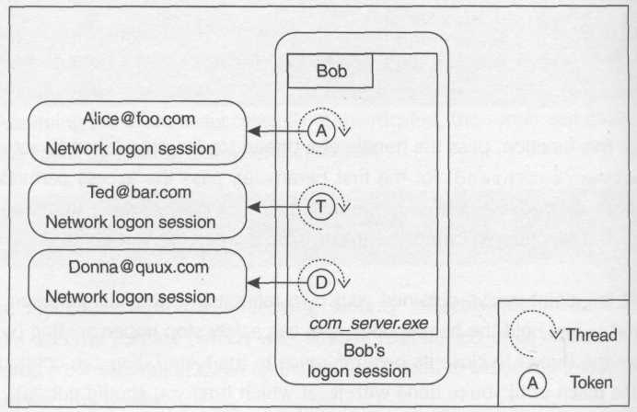
Figure 4.12. The classic impersonation model

Each token has an impersonation level that indicates how the security context may be used, and there are four levels to choose from:

typedef enum _SECURITY_IMPERSONATION_LEVEL
{
SecurityAnonymous,
SecurityIdentification,
SecurityImpersonation,
SecurityDelegation
} SECURITY_IMPERSONATION_LEVEL;

The loosest setting is SecurityDelegation, which indicates that the security context doesn't have any restrictions on its use. If Alice grants this level of impersonation, Bob can happily use her security context to acquire local resources, and (assuming the authentication protocol supports it and the security gods are smiling on him) Bob can use Alice's security context to make authenticated calls on the network, acquiring network resources on Alice's behalf. If Bob makes an authenticated call to Shannon using Alice's security context, Shannon will think the call came from Alice. She'll have no idea that it's really Bob masquerading as Alice.
What's really interesting, though, is that Shannon can now use Alice's security context to talk to Juan, and so on. The only limit on this chain of delegation of Alice's network credentials is that they will expire after a certain amount of time (less than ten hours by default; see Chapter 7 for details). This shouldn't give you a warm fuzzy feeling, though; a bad guy can do a lot of damage in one hour, let alone ten. My own recommendation is to avoid relying on delegation if at all possible. This impersonation level is implemented on Windows 2000, but isn't supported by earlier versions of Windows NT.
A much tighter setting is SecurityImpersonation, whose name is somewhat misleading. Regardless of what impersonation level a token has, you can always take that token and drop it on your thread (thus impersonating). What the impersonation level controls is what sort of things you can do while you're running in the client's security context. If Bob gets a token from Alice at the SecurityImpersonation level, he'll be able to acquire local resources using Alice's security context, but he is not allowed to make authenticated network hops under this guise. This is a requirement for file and Web servers that use authentication and impersonation to stream back requested files to a client. (The file and Web server that ships with Windows requires this, so when you open a remote file, you're implicitly granting this level of trust.) Named pipes, RPC, and COM allow the client to choose the impersonation level programmatically, as demonstrated later.
The preferred setting for applications that shun the impersonation access control model in preference to a role- or object-centric model is security identification, because it keeps honest servers honest. A token with this level of impersonation may not be used to acquire any resources on the client's behalf, not even local resources. As soon as Bob puts a token of this class on his thread, his thread runs in a severely weakened security context. The thread is not allowed to open even local executive objects such as files, processes, and semaphores, because that would violate the trust granted by the client. If Bob tries to call CreateFile, for instance, to open a local file while impersonating, CreateFile will fail and GetLastError will return error_access_denied, which makes sense – the client is denying Bob the right to use his or her security context in this fashion. This impersonation level appears to put the client in control.
So what use is a token in this state? It's of absolutely no use for impersonation, but it has all the client's identity and authorization attributes tucked neatly inside and can therefore be used for performing access checks. Once Bob has Alice's token, he can call GetTokenInformation to see if she's a member of a particular group or alias (this is a form of role-centric access control). He can also call the AccessCheck function (which is discussed in Chapter 6) to perform object-centric access checks.
So, assuming that Bob wants to use one of these more sophisticated access control models, and that Alice can therefore make calls to him granting only SecurityIdentification trust without breaking his code, Bob is now in an interesting conundrum. Remember that the only way Bob can get his hands on Alice's token is to impersonate via CoImpersonateClient (or one of its siblings listed earlier). Recall the code suggested earlier for acquiring the client's token:

HANDLE getClientToken()
{
CoImpersonateClient();
HANDLE htok;
OpenThreadToken(GetCurrentThread(), TOKEN_QUERY, TRUE, &htok);
CoRevertToSelf();
return htok;
}

Let's say Bob uses this function to get a handle to Alice's token. When the call to OpenThreadToken executes, whose security context is the thread running in? It's running in Alice's context because Bob has impersonated Alice. But because Alice has limited her security context to SecurityIdentification, Bob isn't allowed to open executive objects while impersonating Alice, and a token is a first-class executive object. Well, to get Bob out of this pinch, OpenThreadToken takes a third parameter, OpenAsSelf, that can be used to indicate that the system should ignore the fact that the thread is impersonating Alice and should use the process's security context (Bob's token) to do the work.
If you forget this and pass FALSE, OpenThreadToken will fail with access_denied in this case. Chant with me now: I've got job security...I've got job security...
The last setting, SecurityAnonymous, is rather odd, and as far as I can tell, it's only actually implemented for local communication. It also appears to work on the wire with named pipes, but is silently promoted to SecurityIdentification for remote calls using RPC and COM. In any case, this type of token cannot be opened at all. Calls to OpenThreadToken will fail, and GetLastError will return ERROR_CANT_OPEN_ANONYMOUS.
This allows a client to prove to the server that she can be authenticated, but she doesn't want to disclose her identity (whether this is useful is another question entirely).
One very common trap related to trust levels manifests itself via an undocumented feature (or a bug – it's your call) in GetUserName(ex). This function fails if called from within a security context whose impersonation level is less than SecurityImpersonation.
Before leaving this topic, here's a word of advice. Take the guarantees provided by SecurityIdentification and Securitylmpersonation with a grain of salt. First of all, Alice must trust the remote operating system to not allow Bob (the server principal) to misuse Alice's token. If Bob's system is compromised, SecurityIdentification clearly can be upgraded to SecurityImpersonation without Alice's consent. What's critical is that Alice doesn't send her network credentials to Bob, because then the damage wouldn't be limited to the already compromised machine. Another issue arises with local communication specifically when using NTLM authentication (which is what COM uses by default for all local communications as of this writing). NTLM simply copies around tokens when you authenticate with local servers. This means that a local server will have a token to the same physical logon session as the client, and even if the client specifies SecurityImpersonation, local servers will have full access to the client's network credentials. On the other hand, SecurityDelegation means something real: this is a client-controlled limit (among other system controlled limits that I discussed earlier) that helps determine whether her network credentials are sent to remote servers. A bad guy cannot force a client to give up her network credentials without compromising the client's machine.

Restricting Authorization Attributes
Consider a process token. In it are SIDs and privileges, which I refer to generically as authorization attributes. What would happen if you were to remove some of these attributes from the token? Let's consider privileges first. Would the token confer more or less access to the process if it had half as many privileges? Privileges are always used to grant some particular type of access, so it's quite simple: if you remove a privilege from a process's token, you always lower its level of access.
What about a group, though? As mentioned earlier in this chapter, because it's possible to grant access and to deny access to groups, it's not safe to say that removing a group from a process's token would reduce its access. (In practice, it almost always will, but security isn't about saying almost.)
The only way to safely eliminate access from being granted via a particular group SID is to annotate it with the se_group_use_for_deny_only flag in the token. If this sounds interesting, you'll like the following function, which was introduced in Windows 2000:

BOOL CreateRestrictedToken(
HANDLE ExistingTokenHandle, // in
DWORD Flags, // in
DWORD DisableSidCount, // in
PSID_AND_ATTRIBUTES SidsToDisable, // in, optional
DWORD DeletePrivilegeCount, // in
PLUID_AND_ATTRIBUTES PrivilegesToDelete, // in, optional
DWORD RestrictedSidCount, // in
PSID_AND_ATTRIBUTES SidsToRestrict, // in
PHANDLE NewTokenHandle); // out

Given an existing token object opened for token_duplicate permissions, you can call this function to create a new token with restricted authorization attributes. It's pretty clear-cut how to restrict privileges: Simply remove them from the new token. The privileges you'd like to remove are represented by DeletePrivilegeCount and PrivilegesToDelete, and the Flags parameter (whose only valid nonzero value is disable_max_privilege) can be used to indicate that the new token should have no privileges whatsoever.
When dealing with restricting SIDs, if you have a particular SID in mind that you want stripped from the token (at least for the purposes of granting access), the easiest thing to do is to annotate that SID in the new token with the se_group_use_for_deny_only flag. CreateRestrictedToken takes the intersection of the SIDs in the token and the SIDs you specify via the counted array DisableSidCount and SidsToDisable, and sets the deny-only flag for those SIDs (note that you can even restrict the user SID in this fashion).
If you don't know ahead of time which SIDs will need to be disabled in this fashion, but you know which SIDs you're willing to allow the token to use in order to gain access, you can specify them via the counted array RestrictedSidCount and SidsToRestrict. Thus the resulting token will have not only a user SID and a list of group SIDs, but also the list of restricting SIDs that you specified.
Remember how access checks work: the system simply compares a list of SIDs in a token with a list of SIDs in a DACL and grants or denies access appropriately (see Chapter 6 for a more detailed description). When a list of restricting SIDs is present, the system will perform the access check twice, using first the normal list of SIDs (the user SID plus the group SIDs) and then, if that succeeds, making a second check with the list of restricting SIDs. Access is granted only if both these access checks succeed.
With the introduction of restricted tokens in Windows 2000, you need to be very careful about writing code that looks for a particular SID by traversing the user and group SIDs. If the token you're looking at has a list of restricting SIDs, you need to take that into consideration. Windows 2000 will tell you whether or not there is a list of restricting SIDs via the following function:

BOOL IsTokenRestricted(HANDLE TokenHandle); //in

Practically speaking, however, if you need to check for the logical presence of a SID in a token, the safest and easiest way is to simply call CheckTokenMembership:

BOOL CheckTokenMembership(
HANDLE TokenHandle, // in, optional
PSID SidToCheck, // in
PBOOL IsMember); // out

This function takes a token and a SID, and tells you whether an access check would actually use that SID to grant access, and thus whether or not you should consider that SID as being an enabled authorization attribute in the token.
This function doesn't exist in Windows NT 4, but neither do tokens with lists of restricting SIDs. The function is quite easy to implement by hand on both platforms in case you need portable code. An implementation is included here for your convenience; if some of it looks foreign at this point, hang in there – AccessCheck and friends are discussed in Chapter 6.

#if _WIN32_WINNT < 0x0500
BOOL WINAPI CheckTokenMembership(HANDLE TokenHandle,
PSID SidToCheck, PBOOL IsMember)
{
// if no token was passed, CTM uses the effective
// security context (the thread or process token)
if (!TokenHandle)
{
TokenHandle = getEffectiveToken(
TOKEN_QUERY, TRUE, SecurityIdentification);
}

if (!TokenHandle) return FALSE;

// create a security descriptor that grants a
// specific permission only to the specified SID
BYTE dacl[sizeof ACL + _maxVersion2AceSize];
ACL* pdacl = (ACL*)dacl;

InitializeAcl(pdacl, sizeof(dacl), ACL_REVISION);
AddAccessAllowedAce(pdacl, ACL_REVISION, 1, SidToCheck);

SECURITY_DESCRIPTOR sd;
InitializeSecurityDescriptor(&sd, SECURITY_DESCRIPTOR_REVISION);

SID world = {SID_REVISION, 1, SECURITY_WORLD_SID_AUTHORITY,
SECURITY_WORLD_RID};

SetSecurityDescriptorOwner(&sd, &world, FALSE);
SetSecurityDescriptorGroup(&sd, &world, FALSE);
SetSecurityDescriptorDacl(&sd, TRUE, pdacl, FALSE);

// Now let AccessCheck do all the hard work
GENERIC_MAPPING gm = {0, 0, 0, 1};
PRIVILEGE_SET ps;
DWORD cb = sizeof(ps);
DWORD ga;
return AccessCheck(&sd, TokenHandle, 1, &gm, &ps, &cb, &ga, IsMember);
}
#endif

This code implements the documented semantics of CheckTokenMembership, and it works on both Windows 2000 and Windows NT 4 (although for Windows 2000, you'll notice that my implementation is removed by the preprocessor in favor of the implementation provided by the OS).

Restricting Authorization Attributes Using Jobs
If you think that CreateRestrictedToken is neat, just wait until you see what you can do with a job object. Job objects are new to Windows 2000. (If you're not familiar with them, there are existing texts that can give you an introduction.) This section focuses on how to use a job to restrict the authorization attributes of all the processes (and even the threads) in the job. As you'll see, this is really quite a powerful sandboxing mechanism.
A job is a lot like a strip of flypaper. Once you attach a process to a job, you can never remove it (if you try, you'll get error_access_denied). The main goal of the job object is to assign quotas and other types of restrictions on a set of processes, and it's important that a process can't decide to remove those restrictions. In fact, a process can't even get "unstuck" by launching another copy of itself (or of any other program, for that matter); by default, jobs are configured so that all child processes are also associated with the same job, which closes this loophole.
With this in mind, take a look at the security limits that you can place on a job:

typedef struct _JOBOBJECT_SECURITY_LIMIT_INFORMATION
{
DWORD SecurityLimitFlags;
HANDLE JobToken;
PTOKEN_GROUPS SidsToDisable;
PTOKEN_PRIVILEGES PrivilegesToDelete;
PTOKEN_GROUPS RestrictedSids;
} JOBOBJECT_SECURITY_LIMIT_INFORMATION;

#define JOB_OBJECT_SECURITY_NO_ADMIN 0x00000001
#define JOB_OBJECT_SECURITY_RESTRICTED_TOKEN 0x00000002
#define JOB_OBJECT_SECURITY_ONLY_TOKEN 0x00000004
#define JOB_OBJECT_SECURITY_FILTER_TOKENS 0x00000008

The first field is a set of flags that indicate what sort of security limits you'd like to set. The first two flags are pretty straightforward. The first flag (no_admin) blocks processes whose tokens contain the Administrators alias (in the CheckTokenMembership sense) from joining the job. The second flag (restricted_token) blocks processes running without a restricted token from joining the job.
The third flag (only_token) indicates that as each process is added to the job, the system should replace that process's token with the one you specify via JobToken. Normally this will happen automatically as processes that are already in the job create new child processes. In order to make this safe, the process must not have done any work by the time it's added to the job; thus, to add a new process (one that was created outside the job) you need to create the new process in a suspended state, add it to the job, and then call ResumeThread to let it run. AssignProcessToJobObject will fail if you forget to do this.
The last flag (filter_tokens) is the most mind-twisting and cool one of the bunch. This flag indicates that if a thread in a job attempts to impersonate some arbitrary token (even by calling SetThreadToken), the system will take that token and create a new restricted token using the last three counted arrays in the data Structure just Shown: SidsToDisable, PrivilegesToDelete, and RestrictedSids. The restricted token is what will end up on the thread.

Terminating a Logon Session
Think about what it would take to completely terminate a logon session. The operating system would have to terminate all processes using the logon session, and would have to deal with any threads in other processes that are running in the security context of that logon session (via impersonation). What should the operating system do with a thread that's impersonating? Terminate it? Silently stop it from impersonating? Let it keep impersonating but invalidate its token so that each new resource it attempts to acquire fails? It's a hard problem. ExitWindowsEx provides a simple enough solution that works pretty well in most cases.

BOOL ExitWindowsEx(
UINT Flags, //in
DWORD Reserved); // in, ignored

The older sibling, ExitWindows, is simply a macro that expands to a call to ExitWindowsEx (ewx_logoff, 0xffffffff). What's interesting about the documentation for ewx_logoff is that it seems to imply that it terminates a logon session, when in actuality it's much simpler-minded: it simply shuts down all processes whose tokens refer to the logon session of whoever called ExitWindowsEx. As long as no other processes hold open handles to tokens from that logon session, this will naturally terminate the logon session. There are no guarantees, though. This function is sensitive to impersonation, so if a process running as Bob has a thread that is currently impersonating Alice and that thread calls ExitWindowsEx, it will affect processes in Alice's logon session, not Bob's.
One rather bizarre limitation of this function is that it may only be called from a process attached to the interactive window station. (This restriction is discussed further in Chapter 5.)

Summary
- There are several types of logon sessions: the System logon session as well as service, batch, network, and interactive logon sessions.
- The System logon session always exists, and there is only one of these per machine.
- A service is configured by default to run in the System logon session, but can also be configured to run as a distinguished principal, in which case the System SCM will start a new service logon session for the process.
- Another type of daemon logon session is the batch logon, used by the COM SCM. It is virtually indistinguishable (from a practical perspective) from a service logon.
- A network logon session is initiated whenever a remote client is successfully authenticated. Network logon sessions do not normally have network credentials, which is done to protect the clients that they represent.
- Interactive logon sessions are normally produced via Winlogon.
- LogonUser can be used to create new logon sessions, but may only be called from the TCB.
- Tokens represent the surface area of a logon session. The token contains a snapshot of the authorization attributes discovered at authentication time, as well as other settings that affect the security context. Most of these settings are immutable.
- Each process has a token that attaches it to a logon session.
- A thread can override the default security context of the process by impersonating.
- Often impersonation is used simply to eliminate race conditions in a multithreaded program. In this case, ImpersonateSeif is a useful shortcut.
- For historical reasons, there are two types of tokens: primary and impersonation tokens. The only difference is that a primary token can be associated with a process (not a thread), and an impersonation token can be associated with a thread (not a process). Use DuplicateTokenEx if you need to convert between the two types.
- When making an authenticated request via named pipes, RPC, or COM, a client can programmatically specify the level of trust he or she has in the server. This is known as the impersonation level.
- The impersonation level controls how strong or weak a security context the server gets when it impersonates the client. The two most common impersonation levels used in distributed Windows applications are SecurityIdentification and SecurityImpersonation. The former only allows the server to perform access checks and obtain information about the client. The latter allows the server to also obtain local resources (and call GetUserName) while impersonating the client. Prefer SecurityIdentification to protect your clients unless you are using the impersonation model for access control.
- Restricted tokens can be used (on Windows 2000) to limit the authorization attributes in a security context. In the presence of restricted tokens, one must be careful about enumerating SIDs in a token. Prefer to use CheckTokenMembership to check for SIDs in a token, even if you have to roll your own implementation in Windows NT 4 for portability.
- Jobs can be used to automatically apply a policy of restricting tokens in all processes attached to the job.
- ExitWindowsEx can be used to simulate a logoff. This function closes (with optional forcefulness) all processes in the caller's logon session.

LUIDs may be recycled when the machine is rebooted, so technically they don't maintain their uniqueness across reboots, but logon sessions don't persist across reboots either. LUIDs are used in other places as well; see the AilocateLocallyUniqueId API for more detail.
Under Windows 2000, in certain scenarios it is possible (but usually inadvisable) to change this behavior. The details are discussed in Chapter 7.
Technically, with the advent of Terminal Services, this interactive user need not walk up to the machine; rather, he or she may connect via a remote terminal. However, the interactive logon session established by a remote terminal (via Terminal Services) looks and smells so similar to a normal interactive logon session that I don't see the need to distinguish between the two in this book.
Although rpcss.exe is now technically hosted in a service surrogate (svchost.exe), I'll refer to it as rpcss.exe for clarity
Note that an administrator is subject to access checks just like any other principal, but given the privileges normally assigned her, she can get around any DACL that stands in her way. Even if she's not granted a necessary privilege, a clever administrator can ultimately obtain that privilege by changing the local security policy.
A classic trick is to get the Task Scheduler service to start a process on your behalf. The schedule service runs in the System logon session by default, and will happily inject code into the TCB (check out the at command if you want to play with this). This is a cool demo to show off to your friends, but not terribly useful for production code. Only administrators can run at.EXE, by the way.
Technically, even on Windows NT 4, a machine can be authenticated by its primary domain (for the purpose of establishing a secure channel for pass-through authentication), but by no other entity on the network.
I should mention that by using IP Security (which is implemented in Windows 2000), it is possible to authenticate a machine's network address; to make this work, however, some sort of security credentials are required for each machine being authenticated.
If you're looking for a reference on how to implement a service (that is, how to call StartServiceCtrlDispatcher and friends), see Richter (1999b).
This discussion assumes that the COM server in question is not packaged as a service (in that case, the COM SCM simply defers to the System SCM by calling StartService).
Technically, at this point Winlogon executes a helper program known as userinit.exe in the newly established logon session for the client, which sets up the client's environment, restores persistent network connections, runs logon scripts, and then starts the shell. See the MSDN documentation for WlxActivateUserShell for more information.
In Chapter 7 you'll also learn that with Kerberos, it is possible (but inadvisable) to delegate Sarah's credentials across multiple network hops; you'll also learn the hoops you have to jump through to enable this.
Assuming auditing has been enabled (Chapter 6 discusses auditing).
These functions are often used in conjunction with impersonation; their use (and a rather nasty trap to avoid) is discussed later in this chapter.
There is a third flag named se_privilege_used_for_access that you will come across if you scout around in the documentation for using privileges. This flag is not maintained as part of the state of a privilege in a token; rather, it is used to communicate whether or not a particular privilege was used to grant access to a resource.
This works a bit differently for objects arranged hierarchically (files, registry keys, desktops, etc.). See Chapter 6 for details.
This feels very much like a microoptimization, but considering that someone on the Windows team took the time to implement this feature, perhaps one of the subsystems benefited from a caching scheme such as this. (As this book goes to press, I've heard rumors that COM in fact does use this technique internally.)
Be careful not to blindly open the token asking for token_all_access permissions, because this macro includes the undocumented permission token_adjust_sessionid, which you are not granted. This shouldn't generally be a problem, because as explained in Chapter 6, you should avoid asking for all permissions to any object. Instead, only ask for the permissions you really need.
pview.exe works best when run from the System logon session. I often use a tool called cmdasuser (downloadable from my Web site) that allows me to launch PVIEW (and other programs) in the System logon session. (Although useful for debugging and exploratory purposes, injecting random processes into the TCB isn't a good practice in a production system.)
Windows 2000 introduced the negative flavor of logon rights. Earlier versions of Windows only have positive logon rights.
The same hiccup occurs for COM servers if the RunAs principal is not granted the right to a batch-style logon. If auditing has been enabled as suggested, debugging this problem is a cinch.
If you're not getting similar results, be sure to turn off auditing of logon and logoff events on the machine where you're calling LogonUser before you do any performance tests. Also, please don't put too much stock in these actual numbers; your mileage will vary depending on many factors.
If the machine isn't associated with a domain controller, there isn't any appreciable difference in performance between any of the four types of logins (according to my own tests), but this isn't a terribly interesting case for most people.
This LUID looks a lot like the logon session identifier, but it's another LUID that's allocated when the logon session is created. It's not clear why there need to be two LUIDs for identifying each logon session, but this is the way it works. A logon session with ID 0x4242 will have an associated logon session SID that looks similar: S-l-5-5-0-0x4237, for instance.
500 bytes is room enough to store a default owner, primary group, and a DACL with approximately 12 plain-vanilla entries – plenty of space for most applications (if it's not, you should revisit your design and consider using group nesting or aliases). I know of no documented way to adjust this allocation size.
I dedicated a column to this topic in the August 1999 issue of Microsoft Systems Journal. See http://www.develop.com/books/pws for links to all my MSJ articles.
The use of LUIDs was introduced as a level of indirection to allow the future addition of user-defined privileges. This feature is not currently available, however, even in Windows 2000. Perhaps someday.
This technique is not necessary in Windows 2000 domains because, as mentioned earlier, the System logon session does have network credentials in this case.
This is a cute way of saying that there's some configuration you need to tweak to make delegation really work, even in Windows 2000 with Kerberos. See Chapter 7 for the details.
This is the behavior of the Windows 2000 implementation of Kerberos. Other implementations (DCE is the classic example) provide more details on the impersonation chain, but are necessarily much more complex.
See, for example, Richter (1999a).

